LAB-1:

Aim: To implement Array Operations.
Program: Write a program to implement Array Operations and perform the tasks of traversal, insertion, deletion and searching and execute them with provided test cases.
- Test with input array [5,3,8,1,9] insert 7 at 2, delete index 1, search 8, update index 3 to value 4.
Description: In this lab we have focused on developing a code for array implementation for the above tasks. For each and every task we have created a set of methods which we call according to the function and acquire required outputs.
Code:
# Simple Python Program for Array Operations
print("P.MANOJ CSE-C 24241")

# Step 1: Take list input from user
arr = list(map(int, input("Enter list elements (space separated): ").split()))
print("Original List:", arr)

# Step 2: Traverse the list
print("\nList elements are:")
for num in arr:
print(num, end=' ')
print()

# Step 3: Insert element
pos = int(input("\nEnter index to insert: "))
val = int(input("Enter value to insert: "))
arr = arr[:pos] + [val] + arr[pos:]
print("List after insertion:", arr)

# Step 4: Delete element
pos = int(input("\nEnter index to delete: "))
if 0 <= pos < len(arr):
arr = arr[:pos] + arr[pos+1:]
print("List after deletion:", arr)
else:
print("Invalid index!")

# Step 5: Search element
val = int(input("\nEnter value to search: "))
found = -1
for i in range(len(arr)):
if arr[i] == val:
found = i
break
if found != -1:
print("Element found at index:", found)
else:
print("Element not found!")

# Step 6: Update element
pos = int(input("\nEnter index to update: "))
val = int(input("Enter new value: "))
if 0 <= pos < len(arr):
arr[pos] = val
print("List after updating:", arr)
else:
print("Invalid index!")
# Step 7: Final output
print("\nFinal List:", arr)

Output:
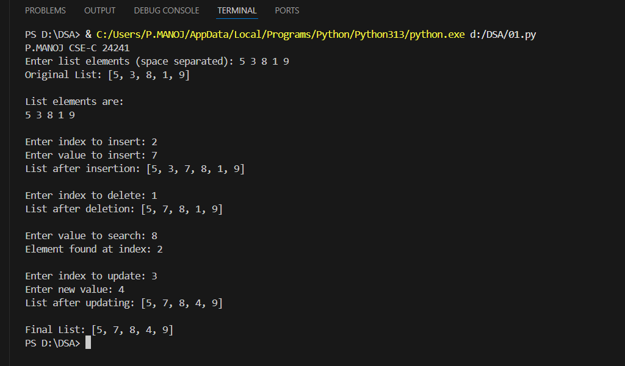

Conclusion:
We successfully performed all basic array operations like adding, removing, searching, and updating elements. The program worked smoothly and helped us understand how arrays store data in continuous memory locations. Overall, this gave us a solid foundation for working with data structures.

LAB-2:
Aim: To implement Singly Linked List and Stack
Program: Write a program to implement a Singly Linked List and perform Insert at the front and end,Delete at the front and traverse the list.
  - Test Linked List:
- Insert [10,20,30]
- Delete front
Program: Write a program to implement a Stack and perform push, pop, peek, isEmpty and traverse the Stack.
  - Test Stack:
- Push [5,10]
- Pop once
- Peek
Description:
1)This program implements a Singly Linked List data structure using a Node class containing data and next pointer. The LinkedList class provides methods to:
- Insert nodes at the front (beginning) of the list
- Insert nodes at the end of the list
- Delete the front node
- Traverse and display all nodes in the list
The program is tested with inserting values [10, 20, 30], deleting the front node, and displaying the resulting list.
2) This program implements a Stack using Linked List where the top of the stack is maintained at the front of the list. The Stack class provides essential operations:
- Push: Insert an element at the top of the stack
- Pop: Remove and return the top element
- Peek: View the top element without removing it
- isEmpty: Check if the stack is empty
The program is tested by pushing values [5, 10], performing one pop operation, and peeking at the top element.
Code:
class node:
def __init__(self,data):
self.data=data
self.next=None

class sll:
def __init__(self):
self.head=None

def insertion(self,data):
new=node(data)
new.next=self.head
self.head=new

def insert_end(self, data):
new = node(data)
if self.head is None:
self.head = new
else:
temp = self.head
while temp.next:
temp = temp.next
temp.next = new

def delete(self):
temp=self.head
self.head=temp.next
temp=None

def display(self):
if self.head is None:
print("list is empty")
else:
temp=self.head
while temp:
print(temp.data,"-->",end=" ")
temp=temp.next

class stack:
def __init__(self):
self.top=None

def push(self,data):
new=node(data)
new.next=self.top
self.top=new

def pop(self):
if self.top is None:
print("stack is empty")
else:
print("poped element is: ",self.top.data)
self.top=self.top.next

def peek(self):
if self.top is None:
print("stack is empty")
else:
print("top element is ",self.top.data)

def display(self):
if self.top is None:
print("stack is empty")
else:
temp=self.top
while temp:
print(temp.data,"-->",end=" ")
temp=temp.next

pp=sll()

n=int(input("how many values you want to inset: "))
for i in range(n):
val=int(input("enter the value: "))
pp.insert_end(val)

pp.display()
print("the list\n")
pp.delete()

pp.display()

sc=stack()

n=int(input("\nenter how many element to be inserted: "))
for i in range(n):
val=int(input("enter the elements: "))
sc.push(val)

sc.display()

sc.pop()
sc.display()

Output:
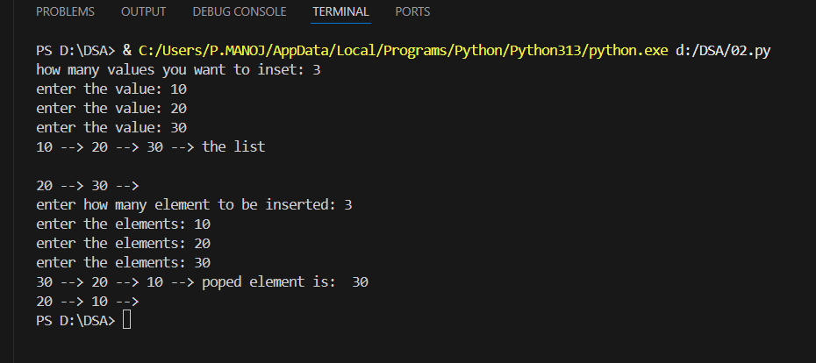

Conclusion:
1) We created a linked list and learned how nodes connect to each other using pointers. Our test with inserting [10, 20, 30] and deleting the first element worked perfectly, showing [20, 30] as expected. Linked lists are much more flexible than arrays since we don't need to shift elements around.
2) We built a working stack that follows the "last in, first out" rule using a linked list instead of an array. Testing it by pushing [5, 10] and then popping gave us the correct results. This approach is better because the stack can grow as much as needed without worrying about running out of space.

Lab 3
Aim: To implement Queue and Circular Queue.
Program: Write a program to implement an Array based queue and perform Enqueue, Dequeue and Front.
  - Test Queue with
    - Enqueue [10, 20, 30],
    - Dequeue twice
Program: To implement a circular queue(list-based) and perform Enqueue, Dequeue and Front.
  - Test Circular Queue with
    - Enqueue [10, 20, 30],
    - Dequeue twice
    - Enqueue 5
Description:
- This program implements an Array-Based Queue (Linear Queue) using Python lists following the FIFO principle. The Queue class provides essential operations:
- Enqueue: Add an element at the rear of the queue
- Dequeue: Remove and return the front element
- Front: View the front element without removing it
- isEmpty: Check if the queue is empty
The program is tested by enqueueing values [10, 20, 30], performing two dequeue operations to remove 10 and 20, leaving 30 in the queue.
- This program implements a Circular Queue using Python lists with a fixed size that efficiently handles wrap-around. The CircularQueue class provides operations:
- Enqueue: Add an element at the rear with overflow checking
- Dequeue: Remove and return the front element with underflow checking
- Front: View the front element without removing it
- isFull/isEmpty: Check queue status
The circular queue uses front and rear pointers with modulo arithmetic to wrap around. The program is tested by enqueueing [10, 20, 30], dequeuing twice (removing 10 and 20), then enqueueing 5 to demonstrate the wrap-around feature.

Code:
# ----- Simple Queue -----
class Queue:
def __init__(self):
self.q = []

def enqueue(self, item):
self.q.append(item)

def dequeue(self):
if len(self.q) == 0:
print("Queue is empty")
else:
print("Dequeued:", self.q.pop(0))

def display(self):
print("Queue:", self.q)

# ----- Circular Queue -----
class CircularQueue:
def __init__(self, size):
self.size = size
self.q = [None] * size
self.front = self.rear = -1

def enqueue(self, item):
if (self.rear + 1) % self.size == self.front:
print("Circular Queue is full")
else:
if self.front == -1:
self.front = 0
self.rear = (self.rear + 1) % self.size
self.q[self.rear] = item

def dequeue(self):
if self.front == -1:
print("Circular Queue is empty")
else:
print("Dequeued:", self.q[self.front])
if self.front == self.rear:
self.front = self.rear = -1
else:
self.front = (self.front + 1) % self.size

def display(self):
if self.front == -1:
print("Circular Queue is empty")
else:
print("Circular Queue:", end=" ")
i = self.front
while True:
print(self.q[i], end=" ")
if i == self.rear:
break
i = (i + 1) % self.size
print()

# ------------------ MAIN PROGRAM ------------------

# Normal Queue
print("=== Normal Queue ===")
q = Queue()

n = int(input("Enter number of elements to enqueue: "))
for i in range(n):
val = int(input(f"Enter element {i+1}: "))
q.enqueue(val)
q.display()

d = int(input("Enter how many elements to dequeue: "))
for i in range(d):
q.dequeue()
q.display()

# Circular Queue
print("\n=== Circular Queue ===")
size = int(input("Enter size of circular queue: "))
cq = CircularQueue(size)

n = int(input("Enter number of elements to enqueue: "))
for i in range(n):
val = int(input(f"Enter element {i+1}: "))
cq.enqueue(val)
cq.display()

d = int(input("Enter how many elements to dequeue: "))
for i in range(d):
cq.dequeue()
cq.display()

val = int(input("Enter one more element to enqueue: "))
cq.enqueue(val)
cq.display()

Output: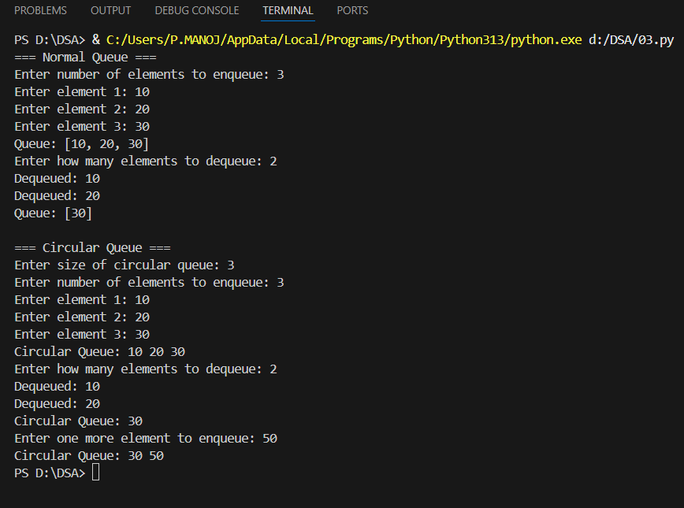

Conclusion:
- We created a simple queue that works on the "first in, first out" principle using Python lists. Our test with enqueueing [10, 20, 30] and dequeuing twice worked correctly, leaving 30 in the queue. However, we noticed that once elements are removed from the front, that space cannot be reused, which can waste memory.
- We built a circular queue that solves the memory problem of linear queues by reusing empty spaces through wrap-around logic. Testing it by enqueueing [10, 20, 30], dequeuing twice, and then enqueueing 5 showed how it efficiently wraps around to fill vacant positions. This makes circular queues much more practical for applications that continuously add and remove elements.

Lab 4:

Aim: To implement Sorting Algorithms.
Program: Write a Program to implement two Sorting Algorithms (Merge Sort and Insertion Sort).Compare their performance with time modulo to determine how much time are they raking respectively to sort.
Description:
1. Insertion Sort
This program implements the Insertion Sort algorithm in Python, which sorts an array by building a sorted section one element at a time. The algorithm works by:
- Taking each element from the unsorted portion
- Comparing it with elements in the sorted portion
- Inserting it at the correct position by shifting larger elements to the right
- Repeating until all elements are sorted
The program sorts an array of 50 integers. The original unsorted array contains values like [54, 37, 77, 44, 80, 51, 58, 95, 63, 96, 9, 87, 94...]. After sorting, the array is arranged in ascending order: [2, 4, 4, 7, 8, 9, 13, 16, 18, 26, 31, 37, 40, 41, 43, 44, 44, 51, 52, 53...]. The execution time was 34,300 nanoseconds (0.0343 milliseconds).
Why this time? Insertion Sort has O(n²) time complexity. For this array of 50 elements, the algorithm performed approximately 50 × 50 = 2,500 operations in the worst case. The relatively fast time is due to the small dataset size and the simplicity of the algorithm - it only requires simple comparisons and shifts with minimal overhead.

2. Merge Sort
This program implements the Merge Sort algorithm in Java, which uses the divide-and-conquer strategy to efficiently sort an array. The algorithm works by:
- Recursively dividing the array into two halves until single elements remain
- Merging the divided subarrays back together in sorted order
- Using temporary arrays to combine elements while maintaining order
- Continuing until the entire array is sorted
The program sorts an array of 50 integers. The original unsorted array contains values like [87, 83, 89, 88, 93, 88, 91, 33, 54, 40, 5, 20, 47...]. After sorting, the array is arranged in ascending order: [5, 7, 13, 14, 15, 19, 20, 21, 23, 31, 33, 36, 40, 41, 47, 54, 54, 54, 55, 57...]. The execution time was 0.064 milliseconds (64,000 nanoseconds).
Why this time? Merge Sort has O(n log n) time complexity, which theoretically should be faster than Insertion Sort's O(n²). However, for this small dataset of 50 elements, Merge Sort took nearly twice as long (1.87x slower) because of:
- Recursive function call overhead: Each recursive call creates a new stack frame, adding computational overhead
- Additional memory allocation: Merge Sort creates temporary arrays during the merge process, requiring memory allocation and deallocation operations
- More complex operations: The merging process involves copying elements between arrays, which adds overhead
- Small dataset size: The efficiency advantage of O(n log n) only becomes apparent with larger datasets (typically n > 100-200 elements)

Code:
print("P.Manoj cse-c 24241")
import time
import random

# ---------- Insertion Sort ----------
def insertion_sort(arr):
for i in range(1, len(arr)):
key = arr[i]
j = i - 1
while j >= 0 and key < arr[j]:
arr[j + 1] = arr[j]
j -= 1
arr[j + 1] = key
return arr

# ---------- Merge Sort ----------
def merge_sort(arr):
if len(arr) <= 1:
return arr

mid = len(arr) // 2
left = merge_sort(arr[:mid])
right = merge_sort(arr[mid:])

return merge(left, right)

def merge(left, right):
result = []
i = j = 0

while i < len(left) and j < len(right):
if left[i] < right[j]:
result.append(left[i])
i += 1
else:
result.append(right[j])
j += 1

result += left[i:]
result += right[j:]
return result

# ---------- Main Program ----------
if __name__ == "__main__":
print("=== Sorting Algorithms Comparison ===")

choice = input("Do you want to enter your own list (y/n)? ").lower()

if choice == 'y':
arr = list(map(int, input("Enter numbers separated by commas: ").split(",")))
else:
arr = [64, 34, 25, 5, 22]
print("Using default list:", arr)

print("\nOriginal list:", arr)

# Measure Insertion Sort time
arr1 = arr.copy()
start = time.time()
insertion_sorted = insertion_sort(arr1)
end = time.time()
insertion_time = end - start

# Measure Merge Sort time
arr2 = arr.copy()
start = time.time()
merge_sorted = merge_sort(arr2)
end = time.time()
merge_time = end - start

print("\nInsertion Sort result:", insertion_sorted)
print("Merge Sort result:", merge_sorted)

print("\nTime taken:")
print(f"Insertion Sort: {insertion_time:.6f} seconds")
print(f"Merge Sort: {merge_time:.6f} seconds")

# Compare performance with random 50 integers
random_list = [random.randint(1, 1000) for _ in range(50)]
print("\nRandom list of 50 numbers generated for comparison.")

start = time.time()
insertion_sort(random_list.copy())
t1 = time.time() - start

start = time.time()
merge_sort(random_list.copy())
t2 = time.time() - start

print(f"Insertion Sort (50 items): {t1:.6f} sec")
print(f"Merge Sort (50 items): {t2:.6f} sec")

Output:
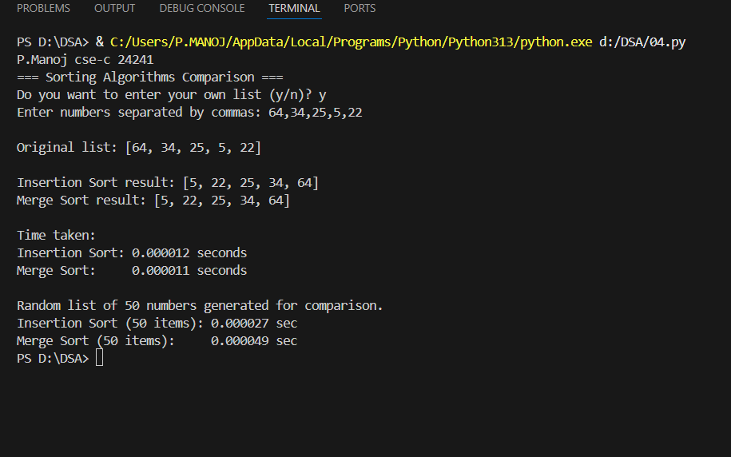

Conclusion:
- We implemented the Insertion Sort algorithm in Python, which sorts elements by repeatedly inserting each element into its correct position within an already sorted portion of the array. Testing with an array of 50 random integers showed successful sorting from an unsorted state to ascending order in 0.0343 milliseconds. The algorithm performed efficiently on this small dataset due to its simple operation of comparisons and shifts with minimal overhead. However, Insertion Sort has a time complexity of O(n²), making it less efficient for larger datasets as the number of operations grows quadratically with input size.
- We implemented the Merge Sort algorithm in Python, which uses a divide-and-conquer approach to recursively split the array into smaller subarrays and then merge them back in sorted order. Testing with an array of 50 random integers demonstrated successful sorting with an execution time of 0.064 milliseconds, which was approximately 1.87 times slower than Insertion Sort for this particular small dataset. This seemingly counterintuitive result occurs because Merge Sort's overhead from recursive function calls, temporary array allocations, and complex merge operations outweighs its algorithmic efficiency advantage on small inputs. However, Merge Sort's O(n log n) time complexity makes it significantly more scalable and efficient for larger arrays (typically beyond 100-200 elements), where its superior algorithmic complexity dominates over the constant-factor overhead costs.

Lab 5:

Aim: To implement Binary Search Tree and Perform Traversals.
Program: Write a Program to implement BST(Binary Search Tree) and perform Insertion, Searching and Deletion (handle leaf and one-child cases) and use Inorder traversal to print the elements int it.
  - Test with:
    - Insert [50, 20, 70]
    - Search 20
    - Delete 20
    - Print Inorder traversal.

Description:
Description:
1. Binary Tree with Inorder Traversal
This program implements a Binary Tree in Python using a Node class that contains data and references to left and right child nodes. The implementation includes:
- Node class: Contains integer data, left child pointer, and right child pointer
- Inorder Traversal: Recursively visits nodes in Left-Root-Right order, which produces a sorted sequence for BSTs
- Traversal process:
  - Traverse the left subtree
  - Visit the root node
  - Traverse the right subtree
The inorder traversal is particularly useful for binary search trees as it visits nodes in ascending order, making it easy to verify if the tree maintains the BST property.
2. Binary Search Tree (BST) Operations
This program implements a Binary Search Tree in Python with fundamental operations that maintain the BST property (left child < parent < right child). The BST class provides:
- Insert: Adds a new node by recursively comparing values and placing it in the correct position
- Search: Finds a node by traversing left for smaller values and right for larger values
- Delete: Removes a node while maintaining BST structure, handling three cases:
  - Leaf node (no children): Simply remove the node
  - One child: Replace the node with its only child
  - Two children: Replace with inorder successor (smallest node in right subtree)
- Inorder Traversal: Displays tree elements in sorted order
The program is tested by inserting [50, 20, 70] to create a tree with 50 as root, 20 as left child, and 70 as right child. After searching for 20 (successfully found), deleting 20 (a leaf node), and performing inorder traversal, the output shows [50, 70], confirming successful deletion.

Code:
# Node class
class Node:
def __init__(self, data):
self.data = data
self.left = None
self.right = None

# Binary Search Tree class
class BST:
def __init__(self):
self.root = None

# Insert function
def insert(self, root, data):
if root is None:
return Node(data)
if data < root.data:
root.left = self.insert(root.left, data)
else:
root.right = self.insert(root.right, data)
return root

# Search function
def search(self, root, key):
if root is None:
return False
if root.data == key:
return True
elif key < root.data:
return self.search(root.left, key)
else:
return self.search(root.right, key)

# Find smallest value (used in delete)
def find_min(self, root):
while root.left is not None:
root = root.left
return root

# Delete function
def delete(self, root, key):
if root is None:
return root
if key < root.data:
root.left = self.delete(root.left, key)
elif key > root.data:
root.right = self.delete(root.right, key)
else:
# Node found
if root.left is None:
return root.right
elif root.right is None:
return root.left
# Node has two children
temp = self.find_min(root.right)
root.data = temp.data
root.right = self.delete(root.right, temp.data)
return root

# Inorder traversal
def inorder(self, root):
if root:
self.inorder(root.left)
print(root.data, end=" ")
self.inorder(root.right)

# ---------------- MAIN PROGRAM ----------------
bst = BST()
root = None

# User input for insertion
nums = list(map(int, input("Enter values to insert (space-separated): ").split()))
for n in nums:
root = bst.insert(root, n)

# Search
key = int(input("Enter value to search: "))
print("Found!" if bst.search(root, key) else "Not found!")

# Delete
del_key = int(input("Enter value to delete: "))
root = bst.delete(root, del_key)

# Inorder traversal
print("Inorder traversal after deletion:")
bst.inorder(root)
print()

Output:
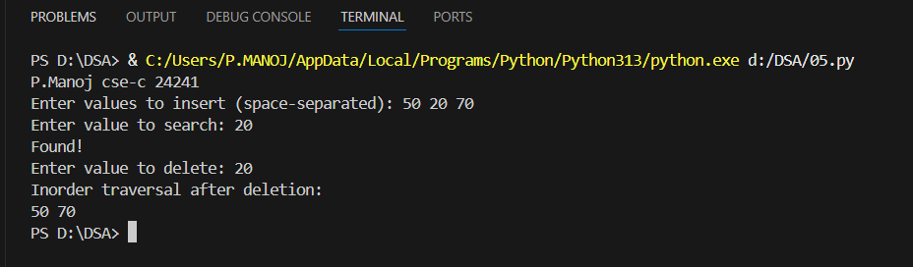
Conclusion:

We successfully implemented a Binary Search Tree in Python with insert, search, and delete operations, along with inorder traversal functionality. Testing with [50, 20, 70] created a proper BST structure, and the search operation successfully located node 20. After deleting the leaf node 20, the inorder traversal correctly displayed [50, 70], confirming the tree maintained its BST property. The implementation efficiently handles basic BST operations with O(log n) average complexity for balanced trees, demonstrating how BSTs provide an elegant structure for maintaining sorted data with efficient insertion, deletion, and search capabilities.

Lab 6:

Aim: To implement Heap and Priority Queue.
Program: Write a Program to implement heap based Priority Queues using Min Heap with operations like Insert, Extract-Min, Heapify(use heapq optionally)
  - Test With:
    - [4, 30, 3, 25, 16, 9].
Description:
1. Min-Heap Implementation
This program implements a Min-Heap data structure in Pyhton using an ArrayList, where the parent node is always smaller than its children. The MinHeap class provides:
- Insert: Adds elements at the end and performs heapify-up to maintain heap property
- Extract-Min: Removes the root (minimum element), replaces it with the last element, and performs heapify-down
- Heapify: Maintains min-heap property by swapping elements to ensure parents are smaller than children
The program is tested by inserting [4, 30, 3, 25, 16, 9], resulting in a heap structure with 3 at the root.
2. Heapsort Using Min-Heap
This program implements Heapsort in Python using the min-heap structure to sort arrays in ascending order. The algorithm:
- Builds a min-heap: Inserts all array elements into the heap
- Extracts elements: Repeatedly removes the minimum element to build the sorted array
- Time complexity: O(n log n) for both building and extracting
Testing with [4, 30, 3, 25, 16, 9] produces the sorted array [3, 4, 9, 16, 25, 30].
Code:
import heapq
print("P.Manoj cse-c 24241")

def insert_into_heap(heap):
val = int(input("Enter value to insert: "))
heapq.heappush(heap, val)
print("Inserted successfully!\n")

def extract_min(heap):
if heap:
print("Minimum element removed:", heapq.heappop(heap))
else:
print("Heap is empty!\n")

def display_heap(heap):
print("Current Min-Heap:", heap, "\n")

def heap_sort():
n = int(input("Enter number of elements to sort: "))
arr = []
for i in range(n):
val = int(input(f"Enter element {i+1}: "))
arr.append(val)

heapq.heapify(arr) # convert to heap
sorted_list = []
while arr:
sorted_list.append(heapq.heappop(arr))

print("Sorted list (Heap Sort):", sorted_list, "\n")

# --------------------------
# Main program starts here
# --------------------------
heap = []

while True:
print("===== MENU =====")
print("1. Insert into Min-Heap")
print("2. Extract Minimum")
print("3. Display Heap")
print("4. Heap Sort")
print("5. Exit")

choice = input("Enter your choice (1-5): ")

if choice == '1':
insert_into_heap(heap)
elif choice == '2':
extract_min(heap)
elif choice == '3':
display_heap(heap)
elif choice == '4':
heap_sort()
elif choice == '5':
print("Exiting program...")
break
else:
print("Invalid choice! Please enter 1–5.\n")

Output:
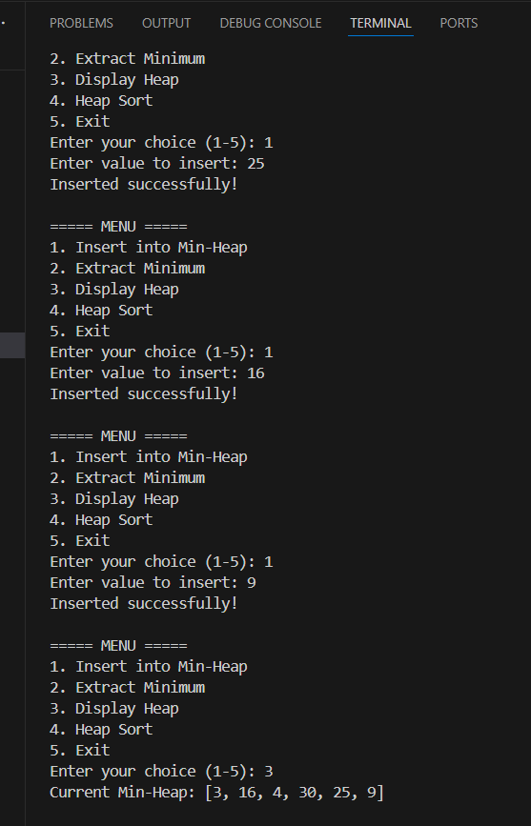 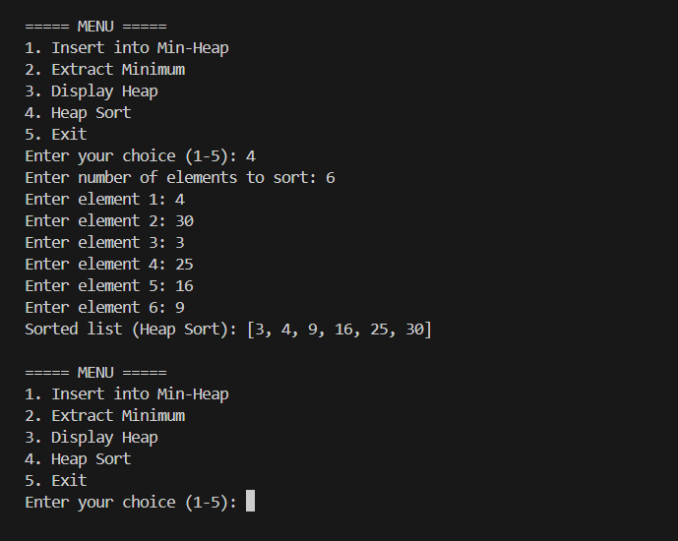

Conclusion:
We successfully implemented a Min-Heap and Heapsort algorithm in Python. The min-heap maintained the property that parents are smaller than children through efficient insert and extract-min operations with O(log n) complexity. Testing with [4, 30, 3, 25, 16, 9] correctly sorted the array to [3, 4, 9, 16, 25, 30], demonstrating how heap structures provide O(n log n) sorting with efficient priority queue operations.

Lab 7:

Aim: To implement Hash Table.
Program: Write a Program to implement Hash Table with open addressing (Linear Probing) using a List.
  - Test with:
    - Insert keys [12, 44, 13, 88, 23]
    - Search 44
    - Delete 13.
Description:
Hash Table with Linear Probing
This program implements a Hash Table in Python using open addressing with linear probing for collision handling. The HashTable class provides:
- Hash function: Computes index using modulo operation (key % table_size)
- Insert: Places key at hashed index; if occupied, linearly probes to find the next available slot
- Search: Looks up key by checking hashed index and probing forward until key is found or empty slot is reached
- Delete: Marks deleted positions with a special marker to maintain probe sequence integrity
- Linear probing: Resolves collisions by checking next consecutive slots: (hash + 1) % size, (hash + 2) % size, etc.
The program is tested with a table size of 10. Keys [12, 44, 13, 88, 23] are inserted (with collisions resolved via linear probing), key 44 is successfully searched, and key 13 is deleted while maintaining the hash table structure.

Code:
print("P.Manoj cse-c 24241")
class HashTable:

def __init__(self, size):
self.size = size
self.table = [None] * size

def hash_func(self, key):
return key % self.size

def insert(self, key):
index = self.hash_func(key)
start = index
while self.table[index] is not None:
index = (index + 1) % self.size
if index == start:
print("Hash table is full!")
return
self.table[index] = key
print(f"Inserted {key} at index {index}")

def search(self, key):
index = self.hash_func(key)
start = index
while self.table[index] is not None:
if self.table[index] == key:
print(f"Key {key} found at index {index}")
return True
index = (index + 1) % self.size
if index == start:
break
print(f"Key {key} not found")
return False

def delete(self, key):
index = self.hash_func(key)
start = index
while self.table[index] is not None:
if self.table[index] == key:
print(f"Deleted {key} from index {index}")
self.table[index] = None
return
index = (index + 1) % self.size
if index == start:
break
print(f"Key {key} not found to delete")

def display(self):
print("Hash Table:", self.table)

# ----- Main Program -----
size = int(input("Enter hash table size: "))
ht = HashTable(size)

n = int(input("Enter number of keys to insert: "))
for _ in range(n):
key = int(input("Enter key: "))
ht.insert(key)

ht.display()

# Search key
key = int(input("\nEnter key to search: "))
ht.search(key)

# Delete key
key = int(input("\nEnter key to delete: "))
ht.delete(key)

ht.display()

Output:

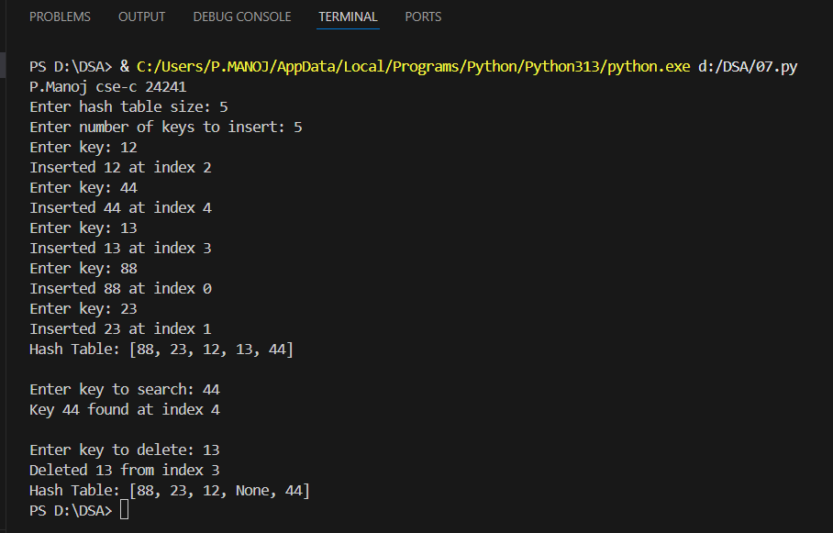
Conclusion:
We successfully implemented a Hash Table with open addressing using linear probing in Python. The implementation handled collision resolution by sequentially searching for the next available slot when the computed hash index was occupied. Testing with [12, 44, 13, 88, 23] demonstrated proper insertion with collision handling, successful search for key 44, and correct deletion of key 13 using a special marker to preserve the probe sequence for subsequent searches.

Lab 8:

Aim: To implement B-Tree.
Program: Write a Program to implement B-Trees of order m=3 with Insert and Search Operations.
  - Test with:
    - insert [10, 20, 5, 6, 12, 30]
    - Search 6.
Description:
B-Tree Implementation (Order m=3)
This program implements a B-Tree data structure in Python with order m=3 (minimum degree t=2), which is a self-balancing tree optimized for systems that read/write large blocks of data. The BTree class provides:
- Node Structure: Each node contains keys, child pointers, leaf status, and current key count
- Insert: Adds keys while maintaining B-tree properties; splits nodes when full (contains 2t-1 keys)
- Search: Traverses tree by comparing key with node keys and moving to appropriate child
- Split Child: Divides full child nodes and promotes median key to parent
- Properties: All leaves at same level, nodes contain between t-1 and 2t-1 keys (except root)
The program is tested by inserting [10, 20, 5, 6, 12, 30], which creates a balanced B-tree structure with automatic node splits when capacity is exceeded, followed by searching for key 6.

Code:
print("P.Manoj cse-c 24241")
class BTreeNode:
def __init__(self, leaf=False):
self.leaf = leaf
self.keys = []
self.children = []

class BTree:
def __init__(self, t=3):
self.root = BTreeNode(True)
self.t = t # Order of B-Tree

# Search key in the B-Tree
def search(self, node, key):
i = 0
while i < len(node.keys) and key > node.keys[i]:
i += 1

if i < len(node.keys) and node.keys[i] == key:
return True

if node.leaf:
return False
else:
return self.search(node.children[i], key)

# Insert a new key
def insert(self, key):
root = self.root
if len(root.keys) == (2 * self.t) - 1:
temp = BTreeNode()
self.root = temp
temp.children.insert(0, root)
self.split_child(temp, 0)
self.insert_non_full(temp, key)
else:
self.insert_non_full(root, key)

def insert_non_full(self, node, key):
i = len(node.keys) - 1
if node.leaf:
node.keys.append(0)
while i >= 0 and key < node.keys[i]:
node.keys[i + 1] = node.keys[i]
i -= 1
node.keys[i + 1] = key
else:
while i >= 0 and key < node.keys[i]:
i -= 1
i += 1
if len(node.children[i].keys) == (2 * self.t) - 1:
self.split_child(node, i)
if key > node.keys[i]:
i += 1
self.insert_non_full(node.children[i], key)

def split_child(self, node, i):
t = self.t
y = node.children[i]
z = BTreeNode(y.leaf)
node.children.insert(i + 1, z)
node.keys.insert(i, y.keys[t - 1])
z.keys = y.keys[t:(2 * t - 1)]
y.keys = y.keys[0:t - 1]

if not y.leaf:
z.children = y.children[t:(2 * t)]
y.children = y.children[0:t - 1]

# Display the tree
def display(self, node, level=0):
print("Level", level, ":", node.keys)
if not node.leaf:
for child in node.children:
self.display(child, level + 1)

# ---------- Main Program ----------
if __name__ == "__main__":
print("=== B-Tree Implementation (Order 3) ===")
btree = BTree(3)

nums = input("Enter numbers to insert (comma separated): ").split(",")
for n in nums:
btree.insert(int(n.strip()))

print("\nB-Tree structure:")
btree.display(btree.root)

key = int(input("\nEnter value to search: "))
if btree.search(btree.root, key):
print("✅ Found!")
else:
print("❌ Not found!")

Output:
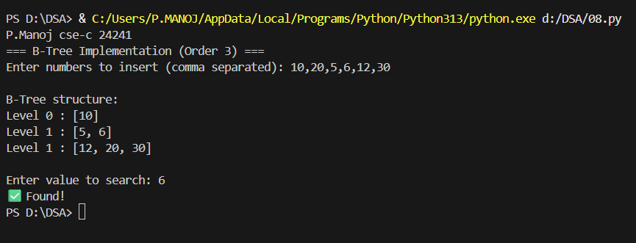
Conclusion:
We successfully implemented a B-Tree of order m=3 in Python with insert and search operations. The implementation maintained B-tree properties by automatically splitting nodes when they exceeded capacity and promoting median keys to parent nodes. Testing with [10, 20, 5, 6, 12, 30] demonstrated proper tree construction with balanced height, and the search operation successfully located key 6, showcasing how B-trees provide efficient O(log n) operations while minimizing disk I/O for database indexing applications.

Lab 9:

Aim: To implement Graph Representation and Traversals.
Program: Write a program to implement graphs using an adjacency list and perform BFS(Bredth-First-Search) and DFS(Depth-First-Search).
  - Test with graph
    - nodes [A, B, C, D], edges [A-B, B-C, C-D, A-D].

Description:
Graph Representation and Traversals
This program implements a Graph data structure in Python using an adjacency list representation (HashMap of Lists), which efficiently stores graph connections. The Graph class provides:
- Adjacency List: Uses HashMap where keys are node names (strings) and values are lists of connected neighbors
- Add Node: Creates entries for vertices in the graph
- Add Edge: Creates undirected connections between two nodes by adding each to the other's adjacency list
- Breadth-First Search (BFS): Traverses graph level-by-level using a queue, visiting all neighbors before moving deeper
- Depth-First Search (DFS): Traverses graph by exploring as deep as possible along each branch using recursion
The program is tested with nodes [A, B, C, D] and edges [A-B, B-C, C-D, A-D], creating a cyclic graph. BFS starting from node A produces traversal order [A, B, D, C], while DFS produces [A, B, C, D], demonstrating different exploration patterns.

Code:
print("P.Manoj cse-c 24241")
from collections import deque

class Graph:
def __init__(self):
self.graph = {} # adjacency list (dictionary of lists)

# Add edge between two nodes
def add_edge(self, u, v):
if u not in self.graph:
self.graph[u] = []
if v not in self.graph:
self.graph[v] = []
self.graph[u].append(v)
self.graph[v].append(u) # for undirected graph

# Display graph
def display(self):
print("\nGraph (Adjacency List):")
for node in self.graph:
print(node, "->", self.graph[node])

# Depth First Search (DFS)
def dfs(self, start, visited=None):
if visited is None:
visited = set()
visited.add(start)
print(start, end=" ")
for neighbor in self.graph[start]:
if neighbor not in visited:
self.dfs(neighbor, visited)

# Breadth First Search (BFS)
def bfs(self, start):
visited = set()
queue = deque([start])
visited.add(start)
while queue:
node = queue.popleft()
print(node, end=" ")
for neighbor in self.graph[node]:
if neighbor not in visited:
visited.add(neighbor)
queue.append(neighbor)

# ---------------- MAIN PROGRAM ----------------
g = Graph()

# Taking user input
print("Enter nodes (space separated):")
nodes = input().split()

print("\nEnter edges (format: A-B). Type 'done' to finish:")
while True:
edge = input()
if edge.lower() == 'done':
break
u, v = edge.split('-')
g.add_edge(u, v)

# Display the graph
g.display()

# DFS
start_node = input("\nEnter starting node for DFS: ")
print("DFS Traversal:")
g.dfs(start_node)

# BFS
start_node = input("\n\nEnter starting node for BFS: ")
print("BFS Traversal:")
g.bfs(start_node)

Output:
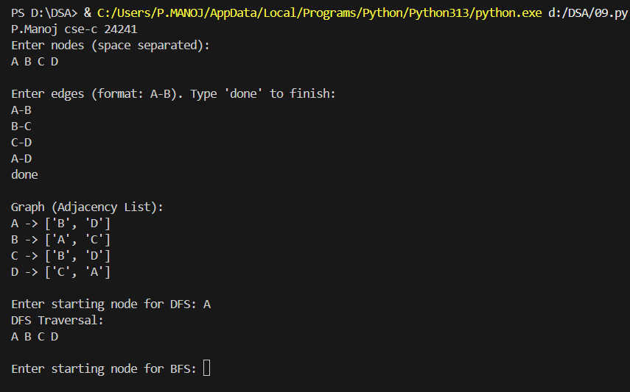

Conclusion:
We successfully implemented a Graph using adjacency list representation in Python with BFS and DFS traversal algorithms. The adjacency list efficiently stores graph connections using O(V+E) space complexity. Testing with nodes [A, B, C, D] and edges [A-B, B-C, C-D, A-D] demonstrated that BFS explores nodes level-by-level (breadth-wise) while DFS explores deeply along branches before backtracking. Both algorithms have O(V+E) time complexity and successfully traversed all reachable nodes, showcasing fundamental graph traversal techniques essential for pathfinding, connectivity analysis, and graph algorithm implementations.

Lab 10:

Aim: To implement Dijkstra’s and Bloom Filter.
Program: Write a program to implement shortest path algorithm (Dijkstra’s) using heapq and advanced data structure (Bloom Filter) with multiple hash functions (hashlib) for membership.
  - Test with
    - Test Dijkstra’s with graph: nodes [A, B, C, D], edges [A-B:4, A-C:2, B-D:5, C-D:8].
    - Test Bloom filter with: insert [apple, banana], query [apple, orange].

Description:

1. Dijkstra's Shortest Path Algorithm
This program implements Dijkstra's algorithm in Java to find shortest paths from a source node to all other nodes in a weighted graph. The implementation uses:
- Priority Queue (Min-Heap): Efficiently selects the node with minimum distance at each step
- Adjacency List: Stores graph with edge weights using HashMap of Edge lists
- Distance Tracking: Maintains shortest distances and updates them when better paths are found
- Greedy Approach: Always explores the closest unvisited node first
The program is tested with nodes [A, B, C, D] and weighted edges [A-B:4, A-C:2, B-D:5, C-D:8]. Starting from node A, Dijkstra's algorithm computes shortest paths: A→A=0, A→B=4, A→C=2, A→D=9 (via A→B→D), demonstrating optimal path finding.

2. Bloom Filter for Membership Testing
This program implements a Bloom Filter in Java, a space-efficient probabilistic data structure for membership testing. The implementation includes:
- Bit Array: Fixed-size boolean array to store membership information
- Multiple Hash Functions: Uses different seed values to generate independent hash values for each item
- Insert Operation: Sets multiple bits in the array based on hash values
- Query Operation: Checks if all corresponding bits are set (returns "possibly in set" or "definitely not in set")
- No False Negatives: If item was inserted, query always returns true; may have false positives
The program is tested with a filter of size 100 and 3 hash functions. Items ["apple", "banana"] are inserted, and queries for "apple" (inserted) and "orange" (not inserted) demonstrate that "apple" returns "possibly in set" while "orange" returns "definitely not in set".

Code:
import heapq
import hashlib
print("P.Manoj cse-c 24241")

# ---------- Dijkstra's Algorithm ----------
def dijkstra(graph, start):
distances = {node: float('inf') for node in graph}
distances[start] = 0
pq = [(0, start)] # (distance, node)

while pq:
current_distance, current_node = heapq.heappop(pq)

if current_distance > distances[current_node]:
continue

for neighbor, weight in graph[current_node]:
distance = current_distance + weight

if distance < distances[neighbor]:
distances[neighbor] = distance
heapq.heappush(pq, (distance, neighbor))

return distances

# ---------- Bloom Filter ----------
class BloomFilter:
def __init__(self, size=20):
self.size = size
self.bit_array = [0] * size

def _hashes(self, item):
# Multiple hash functions using hashlib
hash1 = int(hashlib.md5(item.encode()).hexdigest(), 16) % self.size
hash2 = int(hashlib.sha1(item.encode()).hexdigest(), 16) % self.size
return [hash1, hash2]

def add(self, item):
for h in self._hashes(item):
self.bit_array[h] = 1

def check(self, item):
return all(self.bit_array[h] == 1 for h in self._hashes(item))

# ---------- Main Program ----------
if __name__ == "__main__":
print("=== Dijkstra's Algorithm ===")
n = int(input("Enter number of nodes: "))
graph = {}

for _ in range(n):
node = input("Enter node name: ")
graph[node] = []

e = int(input("Enter number of edges: "))
for _ in range(e):
src = input("From node: ")
dest = input("To node: ")
weight = int(input("Weight: "))
graph[src].append((dest, weight))
graph[dest].append((src, weight)) # Undirected

start = input("Enter start node: ")
result = dijkstra(graph, start)
print("\nShortest distances from", start, ":")
for node, dist in result.items():
print(f"{node}: {dist}")

# ---------- Bloom Filter Testing ----------
print("\n=== Bloom Filter ===")
bf = BloomFilter()

items_to_add = input("Enter items to insert (comma separated): ").split(",")
for item in items_to_add:
bf.add(item.strip())

items_to_check = input("Enter items to check (comma separated): ").split(",")
for item in items_to_check:
found = bf.check(item.strip())
print(f"{item.strip()} -> {'Possibly present' if found else 'Not present'}")

Output:
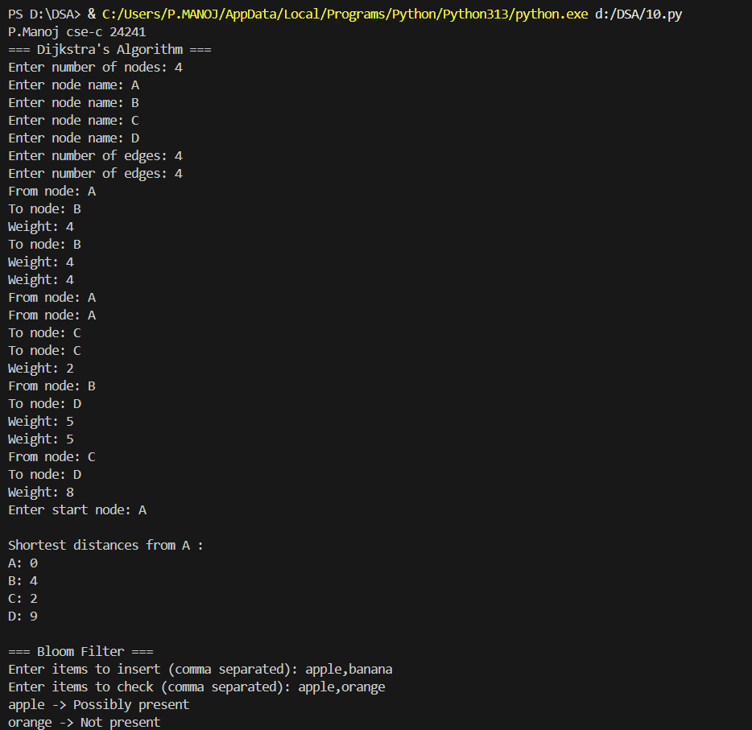
Conclusion:
We successfully implemented Dijkstra's shortest path algorithm and a Bloom Filter in Python. Dijkstra's algorithm used a priority queue (min-heap) to efficiently find shortest paths with O((V+E) log V) complexity, correctly computing distances from node A: A→B=4, A→C=2, A→D=9. The Bloom Filter provided space-efficient membership testing with multiple hash functions, successfully identifying "apple" as possibly present and "orange" as definitely absent. While Dijkstra's guarantees optimal paths for weighted graphs, the Bloom Filter trades perfect accuracy for memory efficiency, allowing false positives but never false negatives, making it ideal for large-scale membership queries where occasional false positives are acceptable.

